

Digital Show Room User Guide

Virtual/Online Store



Technical Writer: Ravikiran K C

Contents

1. About the Product 2

1.1 Introduction 2

1.2 Audience 2

2. Installing the App 2

3. Menu Bar 3

4. Getting Started 3

5. Adding the Products 5

6. Selling the products 6

7. Viewing the Customer Orders 6

8. Settings 7

## About the Product

### Introduction

Digital Showroom aims to empower small businesses and individual business owners to take their business online – enabling WhatsApp Marketing, Digital Commerce, and Integrated UPI Payments by connecting with customers through WhatsApp.

Dotpe has multiple products aimed at different sectors within the retail environment. It has launched the Digital Showroom. This technology provides start-up E-commerce and payment platforms to offline enterprise businesses to drive digital transformation in selling, managing, and engaging with your customers. It enables companies to sell more, sell directly, and sell efficiently.

### Audience

This guide is intended for retail shoppers, distributors, and aspiring retailers looking to establish a digital presence for their shops.

## Installing the App

To install Digital Showroom on your Android Phone.

1. On your Android phone, open the **Play Store**.
2. Search **Digital Showroom: Online Dukan,** click **Install.**

To install Digital Showroom on your iPhone or iPad.

1. On your iPhone or iPad, open the **App Store**.
2. 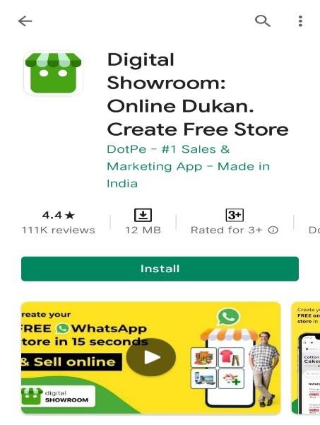Search **Digital Showroom: Online Dukan,** click **Install.**

## Menu Bar

This section provides brief information about the menu’s list.

|  |  |
| --- | --- |
| **Menu Bar** |  |
| **My Order** | After you get the orders, the customer list will appear in the **My Order** section. |
| **My Money** | Displays the transaction history in the **My Money** section. |
| **My Products** | Displays the product list in the **My Products** section. |
| **Promote Your Store** | Provides many options to promote your store. |
| **Settings** | You can edit the Store Name, and your store Description, Reference the app,  and Lag out options in the **Settings** section. |

## Getting Started

Follow the below steps to get started:

1. Open **Digital Showroom** and click **Start Now.**

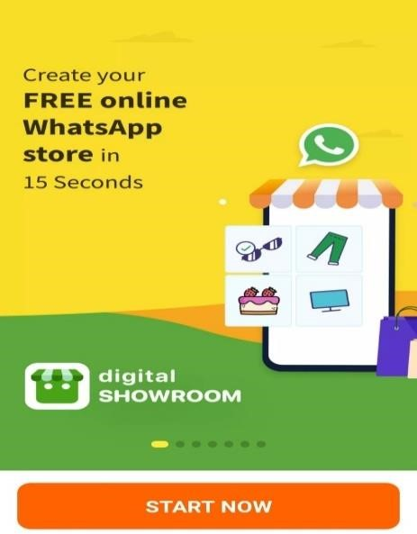

1. Enter a **WhatsApp Number**, click **Get OTP.**
2. 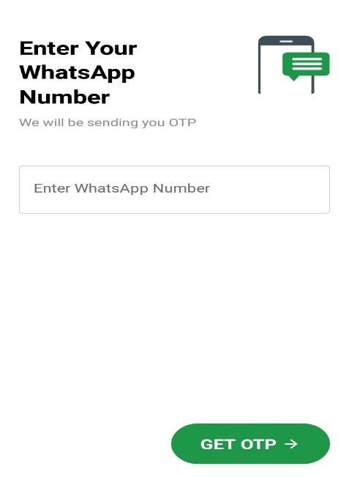Enter **OTP** and verify your **Phone Number.**
3. Enter your **Shop name,** then click **Next.**   
   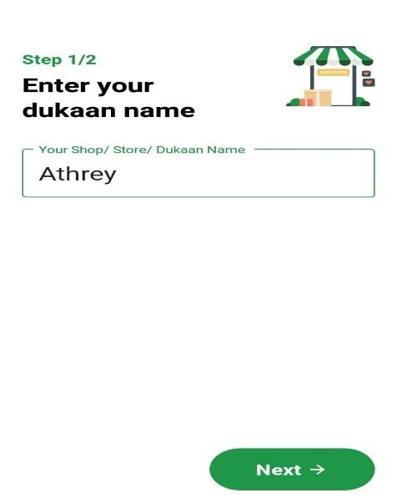

1. On the **Add Bank Account** page.
2. In the **Select your bank** field, type your bank name and select the bank.

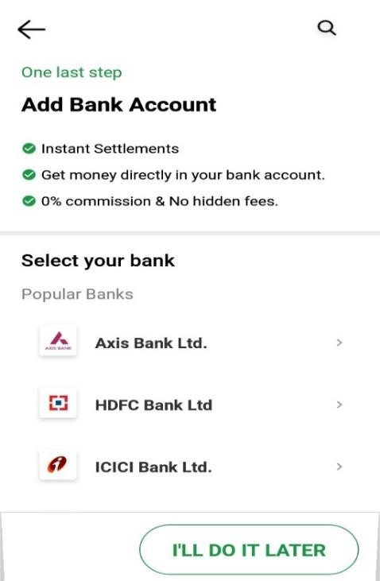

1. After adding a bank account, you will get the following features:

* You can make instant settlements
* Get money directly into your bank account
* 0% commission and no hidden charges

Or   
Click  for adding a bank account later.

1. Loading **Creating your online stor**e.   
   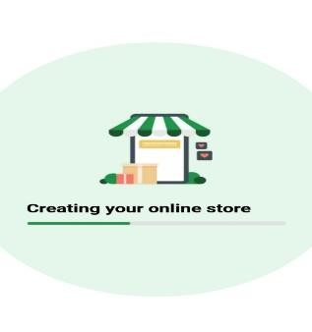
2. The **My Order** page shows a welcome message with your **store** **name** appearing on it.

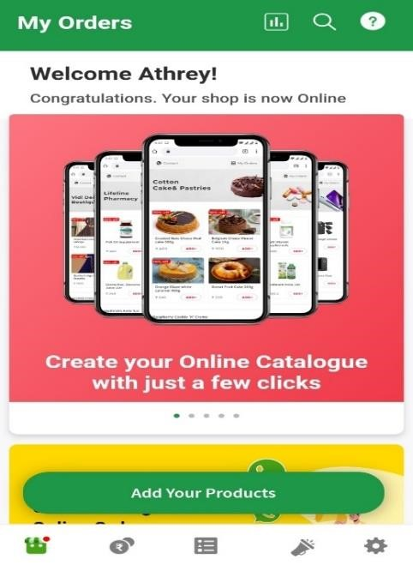

## Adding the Products

Follow the below steps to add products:

1. On **Add Item**, add the following details:
   * Upload your product image
   * Item Name & Size
   * Price
   * Category Name (Optional)

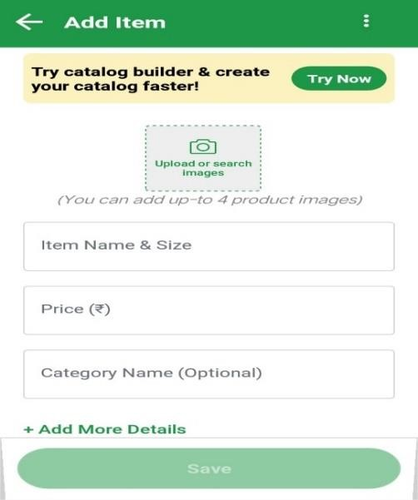   
**Note:** You can add more details by selecting the **+ Add More Details**

1. Click **Save**.
2. To add more products, click **.**
3. After adding products, you can view all products in **My Products**.

## Selling the products

Follow the below steps to sell the products:

1. On **My Products**, click **Share Shop** to share your products with your customers.

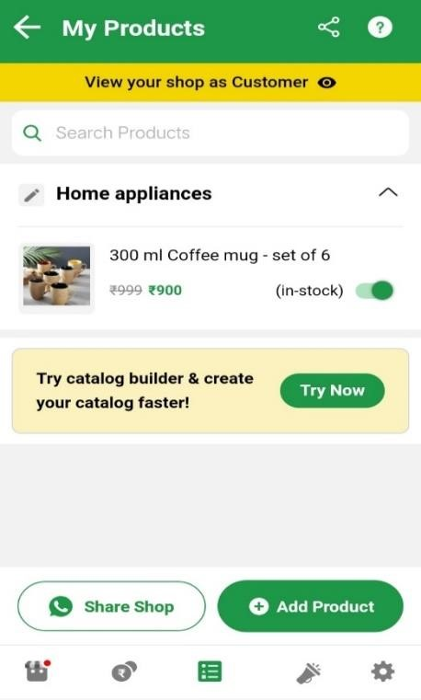

## Viewing the Customer Orders

After you start selling the product, the customer can place their orders.

To view the customer’s orders, select **My Orders** or click icon.

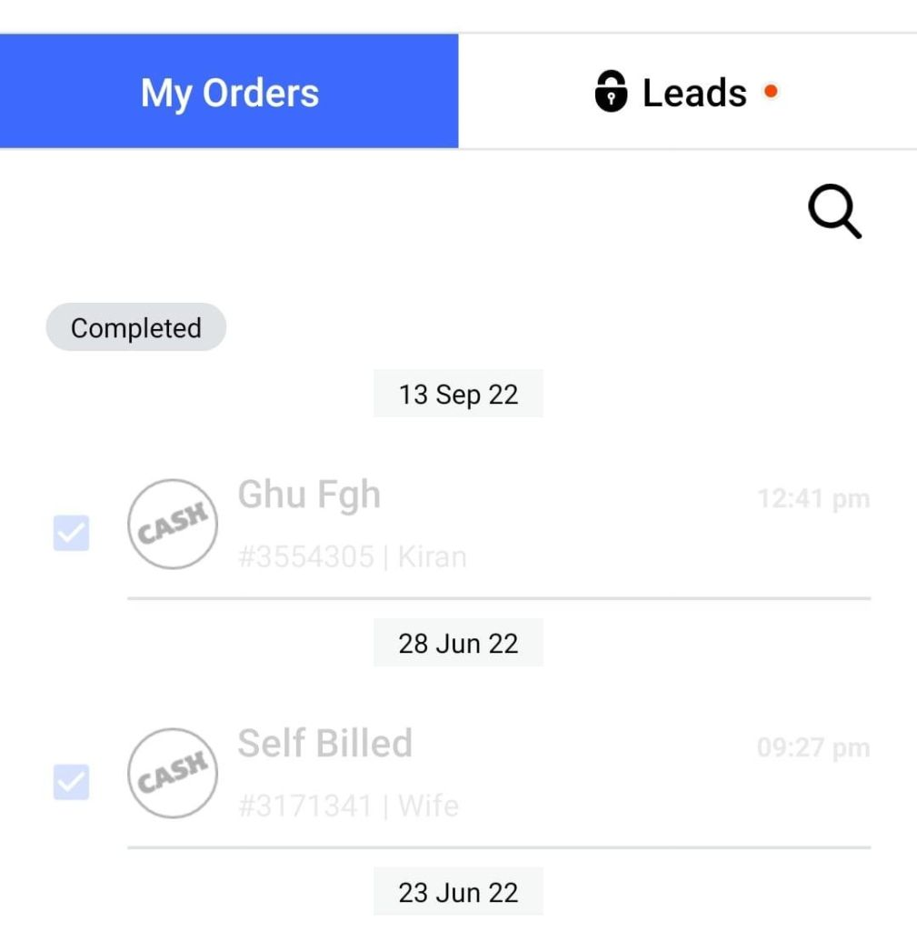

## Settings

In settings, you will get the following features:

* On **Settings**, you can upload your store logo, edit your store name, and add a brief introduction about the store.
* Keep **On** the below options during the store's open hours:
  + Store Status as Open
  + Delivery as Available
* To share your product catalog with your customers, click **Share Shop**.
* To refer to this app with your business partners, click **Refer this App**.
* To view your shop in web mode or the browser, click **Digital Showroom Web**.

